Year 9 Music Major ‘What a Classic’
Creating Task

Your task in this unit of work is to develop a musical motif into two short compositions. Your compositions will be written in any two of the following musical genres.
- Baroque
- Classical
- Romantic
- 20th / 21st Century
Each piece should show your understanding of the particular genre through your treatment of the musical elements
- Structure
- Pitch (melody, harmony, tonality)
- Duration (rhythm, meter and tempo)
- Texture
- Tone colour/timbre
- Dynamics
The table below outlines some of the musical features of each style, and can be used to guide your composition process (you are not expected to include all of the features below in your work, just enough to enable your pieces to reflect each genre).
 | Baroque | Classical | Romantic | 20th / 21st Century
Structure / Form | Ritornello form  Concerto Grosso  Dance Suites  Binary form | Balanced phrases, often 8 bars  Clear Sonata form  Theme and Variations  Rondo  Minuet and trio | Irregular phrase lengths  Extension of classical forms | ‘Neo-Classical’  Impressionistic  ‘Chance Music’ (no set structure)  32 bar AABA Song structure/12 bar blues
Melody | Sequences  Ornamentation | Lyrical / Conjunct  Question and answer phrases | Use of folk melodies  Use of extreme high and low registers | Angular / Disjunct  Absence of melody / minimalist (music may focus primarily on rhythmic elements)
Harmony | Diatonic  Less frequent modulations  Basso Continuo | Diatonic  Modulations often dictated by musical forms (ie Sonata form)  Traditional modulations  IV/V/relative minor/tonic minor | Increased dissonance  Distant modulations | Atonal / 12 tone
Rhythm | Extensive use of repetition | Use of rhythmic motifs | More complex and varied rhythmic structures/motifs | Polyrhythmic
Metre | Sustained | Varies between movements/variations, but rarely within a movement or variation | More varied (often within a single piece or movement) | Polymetric structures  Extreme and frequent changes of metre  Lack of metre all together
Tempo | Sustained | Varied between movements | Frequent and often dramatic tempo changes | Extreme tempo changes
Dynamics | Terraced Dynamics  Sustained passages at one dynamic level | Increased use of diminuendo and crescendo | Extreme dynamic contrast  Use of ppp - fff | Exploration of the complete dynamic range  Use of technology to make music appear louder (pop music)
Texture | Polyphonic / Contrapuntal | Homophonic | Combination of different musical textures, but often homophonic | All musical textures used
Timbre/Tone Colour | Strings  Organ  Lute/recorder/flute | Classical orchestra  Increased use of woodwind instruments  Purity of tone | Extensive use of brass and percussion  Greater range of tone colour | Extended techniques
Other |  | Increased use of expressive elements  Restrained articulation | Nationalistic  Programmatic (music often tells a story)  Greater range of articulation | Graphic notation  Electronic music  Microtonal music

Your work will be submitted as a score, performance and written reflection on the process. Your reflection should focus on which musical features you have incorporated into your work, and how successfully your work portrayed the features of each genre.
Here is the opening phrase in both the treble and bass clef.
You have also been sent a Sibelius file containing this short excerpt, which you can open using the computers in the Digital Music Lab.
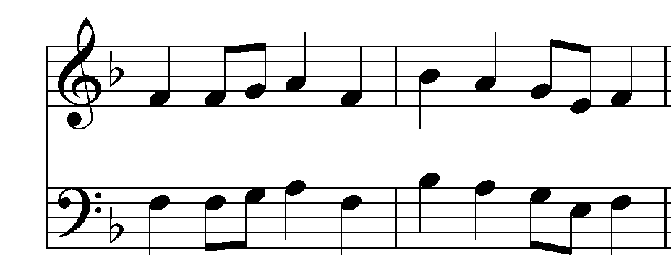
Feel free to add additional parts as required, but remember you need to have the piece performed in class on Wednesday 27 August.

